**<< Sandwich Maker >>**

Software Requirements Specification

For “Sandwich Maker” System

Version <5.0>

**Submitted by:**

1. Alina Kharkevich – s22168

2. Lizaveta Babior – s22355

3. Anastasiya Sukach – s23566

4. Daria Dronova – s22653

**Revision History**

|  |  |  |  |
| --- | --- | --- | --- |
| **Date** | **Version** | **Description** | **Author** |
| 16.10.2022 | 1.0 | First common version of project. | All members |
| 24.10.2022 | 2.0 | UD and CLD diagrams added; language improvements. | Alina Kharkevich |
| 09.10.2023 | 3.0 | UD and Use-Case requirements improvements; UD and CLD diagrams improvements. | Alina Kharkevich |
| 10.01.2023 | 4.0 | UD and Guest/User improvements, GUI mock-up added. | Alina Kharkevich |
| 19.01.2023 | 5.0 | Last details and improvements, numeration, style changes. | Alina Kharkevich |

**Submitted to:** ....................................

**Date of submission:** ......................

**Table of Contents**

**Revision History............................................................................................................................ 0**

**Contents......................................................................................................................................... 1**

1.0. Introduction 2

1.1. Purpose 2

1.2. Scope of Project 2

1.3. Glossary 2

1.4. References 3

1.5. Overview of Document 3

2.0. Overall Description 4

2.1. Use-Case Model Survey 4

2.2. Assumptions and Dependencies 9

3.0. Requirements Specification 10

3.1 Functional Requirements 10

3.2 Use-Case Requirements 12

3.3 Non-Functional Requirements 18

4.0. GUI Realization 19

4.1. Mock-up Examples 19

5.0. Supporting Information 29

5.1 Index 29

# Introduction

## 1.1. Purpose

This Software Requirements Specification will present detailed description of the “Sandwich Maker” System. This document is intended for both: users and the developers; and explains the purpose, interfaces, constraints and requirements which have a high priority for the system.

## 1.2. Scope of Project

This software system will be a “Sandwich Maker” System for local residents who want to order take-away sandwiches. This system will be designed to maximize the “Sandwich Maker” Pick-up Points productivity by providing tools to automatically assist orders, what would otherwise have to be performed manually. By automatization of the process of making and registering orders, generating of Custom Sandwiches, creating and renewing Stop List, we maximize the “Sandwich Maker” work efficiency and satisfy customers’ needs.

Specifically, our system allows customers to choose location of Pick-up Point from the list, choose Standard Positions to order or/and generate Custom Sandwich from available products, make an order and pay by Card online or by Cash in chosen Pick-up Point. For assistants it helps to track orders and payments, renew and submit Stop List.

## 1.3. Glossary

|  |  |
| --- | --- |
| **Term** | **Definition** |
| Guest | Unauthenticated user, who need to Log in or Sign up first. |
| User | Customer or Assistant who are logged into the system. |
| Stop List | Menu positions and ingredients with availability changes. |
| Standard Position | Standard food item in the menu. (French fries, Coca-Cola, etc.) |
| Custom Sandwich | Sandwich generated from chosen ingredients by customer. |

## 1.4. References

* IEEE. IEEE Std 830-1998 IEEE Recommended Practice for Software Requirements Specifications. IEEE Computer Society, 1998.
* en.wikipedia.org for definitions

## 1.5. Overview of Document

The second chapter, the Overall Description section, gives an overview of the functionality of the product needed for establish a context for the technical requirements later. The third chapter, Requirements Specification section, is mainly for the developers and describes details of the functional and non-functional requirements of the product. Finally, the last chapter called GUI Realization shows intended interface of “Sandwich Maker” application.

All these sections of the document describe the Sandwich Maker system, but in different angles of future reader.

# 2.0. Overall Description

The goal of the system “Sandwich Maker” is to provide functionalities for authorizing, making orders, managing orders, and storing them. The Sandwich Maker system has 5 active actors and one cooperating system. The Guest has an option to Log in or Sign up. If the Guest is authorized as Customer, he can make an order, view the status of his order. If the Guest is authorized as Assistant, he has options to create a Stop List, view the list of orders, manage the status of orders. Any User (Customer or Assistant) can view their Personal Data in “My Account” menu. Time actor is responsible for managing payment process, Stop List updating and registering new Guests.

## 2.1. Use-Case Model Survey

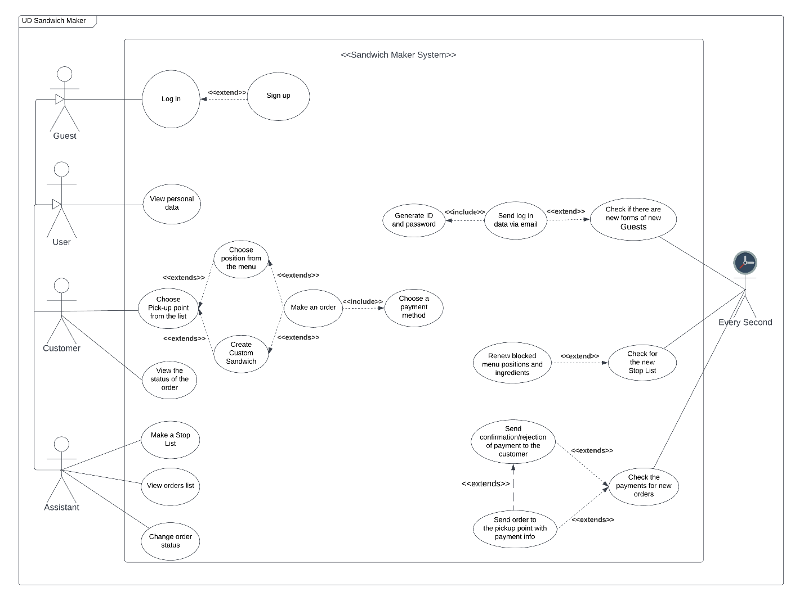

*Picture 1 – Use-Case Diagram*

The section below outlines the use cases for each of active actors separately.

*2.1.1 Guest Use-Case*

*Use-Case*: “Log in”

*Diagram*:

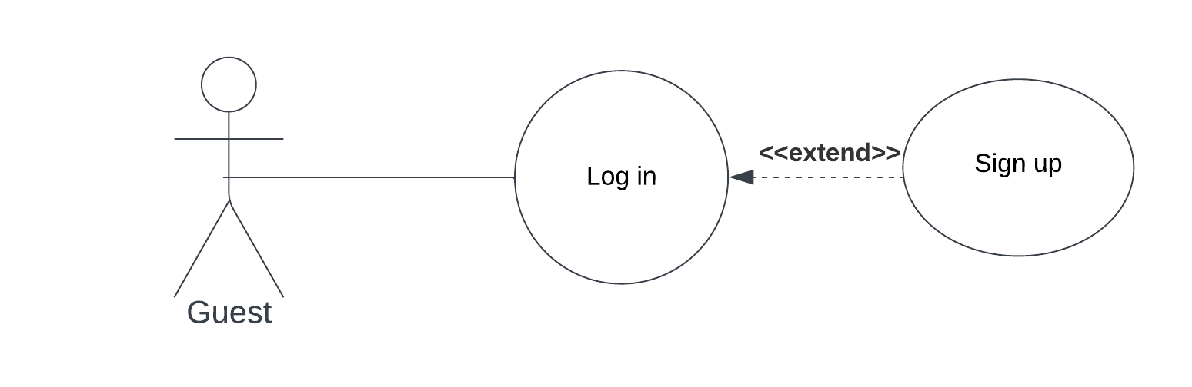

*Brief Description*:

The *Guest* opens the “Sandwich Maker” application and enters ID and Password in Log in page dashboard.

*Initial Step-By-Step Description*:

1. The Guest presses the button “Log in”.
2. The System displays Log in Page.
3. The Guest enters ID and password.
4. The Guest presses the button “Submit.”
5. The System displays Main Page for an authorized User.

*Xref:* 01.X.X Log in

*2.1.2 User Use-Case*

*User-Case*: “View personal data”

*Diagram*:

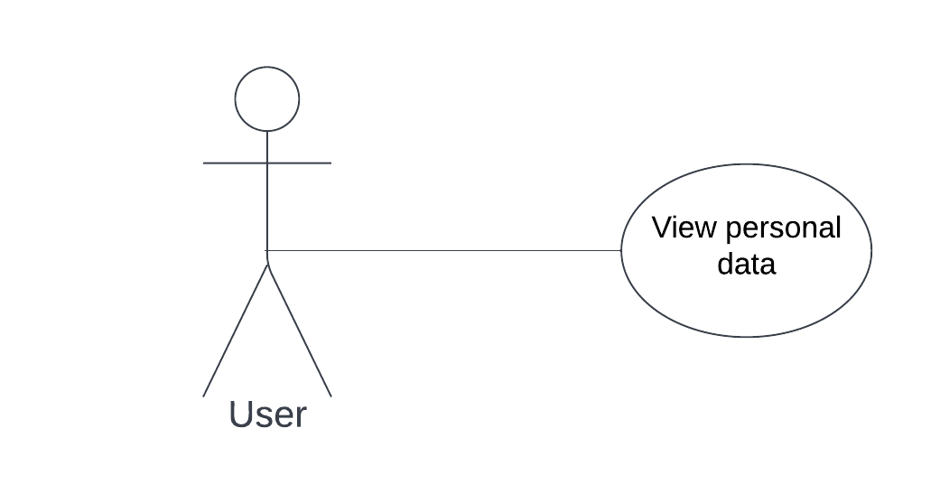

*Brief Description*:

The User view his personal data (Name, Surname, Email, Phone number).

*Initial Step-By-Step Description*:

1. The User press the button “My Account”.
2. The System displays My Account Page.
3. The User press the button “Personal Data”.
4. The System displays personal data (Name, Surname, Email, Phone number) of the User.

*Xref:* 02.X.X View personal data

*2.1.3 Customer Use-Cases*

*Use-Case:* “Make an order”

*Diagram*:

*Brief Description:*

The Customer places an order in the system.

*Initial Step-By-Step Description:*

Before this Use -Case can be initiated, the Customer has already authorized as valid User of role Customer.

1. The Customer clicks “New Order” button.
2. The System displays Pick-up Point Page with the list of Pick-up Points.
3. The Customer chooses the Pick-up Point form the list.
4. The Customer clicks the button „Submit”.
5. The System displays Menu Page of chosen Pick-up Point.
6. The Customer chooses positions from the menu and its number.
7. The Customer clicks the button „Submit”.
8. The System displays Payment Page.
9. The Customer chooses payment method.
10. The Customer clicks the button „Submit”.
11. The System displays „Thank you for your Order” Page.
12. The Customer clicks “Main Page” button.

*Xref*: 03.X.X Make an order

*Use-Case*: “View the status of the order”

*Diagram*:

*Brief Description:*

The Customer checks the status of his orders.

*Initial Step-By-Step Description*:

Before this use case can be initiated, the Customer has already authorized as valid user of role Customer.

1. The Customer clicks the button “My Account”.
2. The System displays My Account Page.
3. The Customer clicks the button “View Order Status”
4. The System displays status of his orders.

*Xref*: 04.X.X View the status of the order

* + 1. *Assistant Use-Cases*

The Assistant has the following set of use cases:

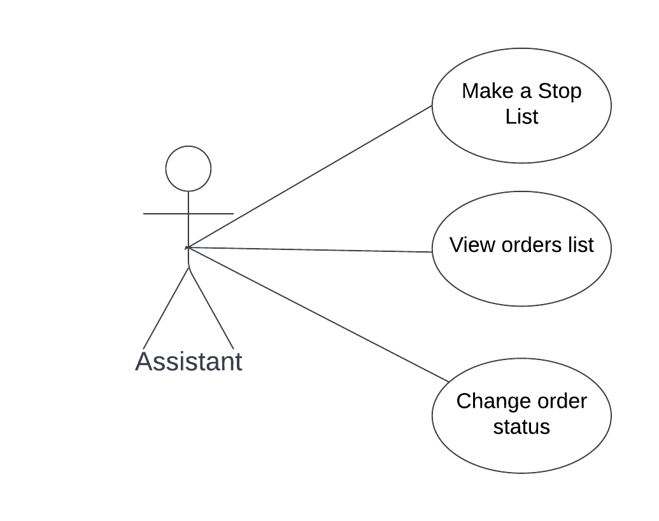

*Use-Case*: “Make a Stop List”

*Diagram*:

*Brief Description*:

The Assistant enters Standard Positions or/and ingredients with changes in availability.

*Initial Step-By-Step Description*:

Before this Use-Case can be initiated, the Assistant has already authorized as valid User of role Assistant.

1. The Assistant clicks the button “My Account”.
2. The System displays My Account Page.
3. The Assistant clicks the button “Make Stop List”.
4. The Assistant enter changes in availability of Standard Positions and ingredients and their quantity.
5. The Assistant clicks the button „Submit”.

*Xref*: 05.X.X Make a Stop List

*Use-Case*: “View orders list”

*Diagram*:

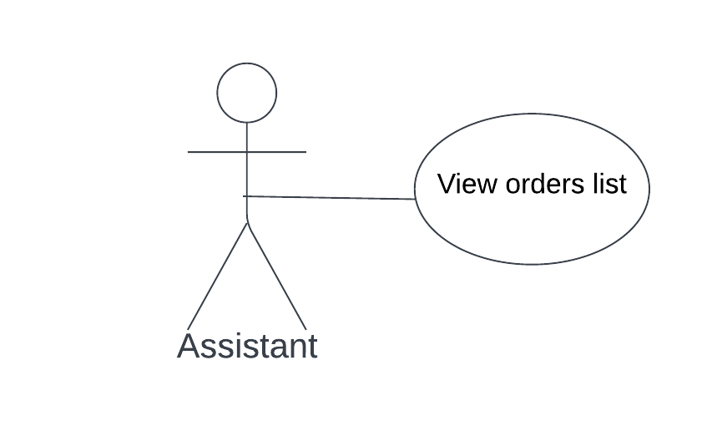

*Brief Description:*

The Assistant views the list of all orders of the Pick-up Point.

*Initial Step-By-Step Description*:

Before this Use-Case can be initiated, the Assistant has already authorized as valid User of role Assistant.

1. The Assistant clicks the button “My Account”.
2. The System displays My Account Page.
3. The Assistant clicks the button „View Order List”.
4. The System displays the list of orders with payment info.

*Xref*: 06.X.X View the list of orders

*Use-Case*: “Change order status”

*Diagram*:

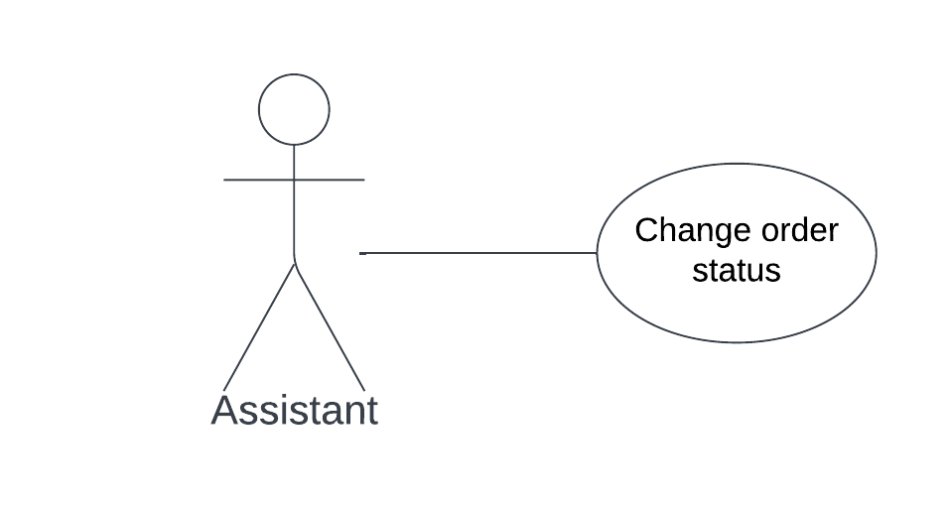

*Brief Description*:

The Assistant changes order status.

*Initial Step-By-Step Description:*

Before this Use-Case can be initiated, the Assistant has already authorized as valid User of role Assistant.

1. The Assistant clicks the button “My Account”.
2. The System displays My Account Page.
3. The Assistant clicks the button “Change Order Status”.
4. The System displays the list of orders.
5. The Assistant choses the order from the list.
6. The Assistant changes the status of the order.
7. The Assistant clicks the button “Submit”

*Xref*: 07.X.X Change order status

## 2.2. Assumptions and Dependencies

“Sandwich Maker” is required to have high-speed internet, modern computers, and pre-installed software with Operating System Windows 8 or higher. The User should also have high-speed internet to be able to access the web-application.

# 3.0. Requirements Specification

## Functional Requirements

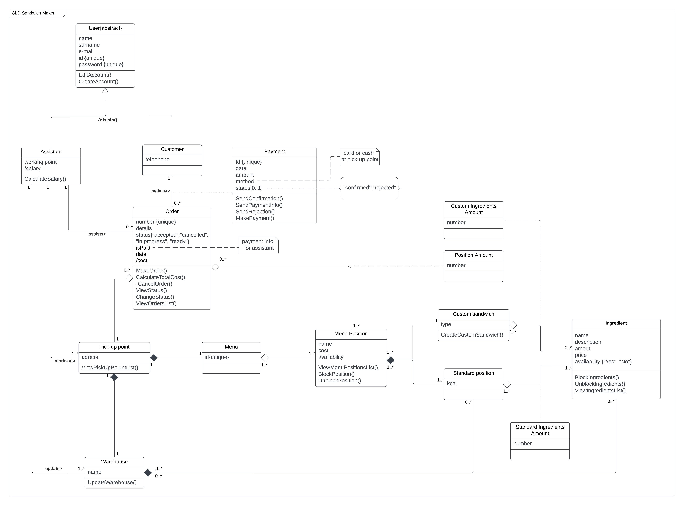

*Picture 2 - Class Diagram*

***Actors:***

1. “Guest” – is an Abstract actor. Any Guest can Log in or Sign up to be identified.
2. “User” – is an Abstract actor, it can be Customer or Assistant. Any User can view their personal data in My Account Page.
3. “Customer” – is a client who can make an order, view status of his orders.
4. “Assistant” – is an employee who can check the list of orders, change the status of order, make a Stop List.
5. “Every second” – is a Time Actor.

***Requirements:***

* Application provides authorization and access restriction through the system of accounts and user roles.
* Guest has to Log in (and Sign up if it is a first usage) in order to use an application.
* Any User (Customer or Assistant) can see their personal data (Name, Surname, Email, Phone number).
* Customer who is logged in has opportunity to:
  + Choose any Pick-up Points from the list.
  + Choose any position from menu which is available (all unavailable positions are not displayed in the customers menu).
  + Make a Custom Sandwich.
  + Place their order.
  + To choose payment method (Card or Cash).
  + Pay by Card in the system (and by Cash at the Pick-up Point).
  + See status of all their orders.
* Assistant who is logged in has opportunity to:
  + Make and update Stop List.
  + View the list of orders.
  + Change order status.
* Every Second – is a Time Actor (System) must check every second:
  + Is there any new Card payment from customers and send confirmation or rejection to the customer by email.
  + Send order data to the Pick-up Point with payment info.
  + Check for the new Stop List and block/unblock positions in the menu.
  + Check if there is a new Sing up form from new Guest, generate new ID and password and send new Guests Log in data via provided email.

## Use-Case Requirements

1. “Check the payments for new orders”

|  |  |
| --- | --- |
| Function Name | Check the payments for new orders |
| Actor | Time Actor - Every Second |
| Trigger | Every second |
| Precondition | System is not freezed and every second check successfully continuing. |
| Postcondition | * Customer got a confirmation message, and the order was sent to Pick-up Point with payment info “Paid by Card”. * Order without payment and with the payment method “Card” was sent to the Pick-up Point with payment info “Pay by Cash”. |
| Basic Path | 1. Every second the System checks if there are new payments for new orders.  2. The System finds new payment made by Card.  3. The System sends confirmation to the customer by email about receiving the payment.  4. The System sends order data to the Pick-up Point with payment info “Paid by card”. |
| Alternative Path | 1. The System does not find a new payment for a new order with payment method “Card”. 2. Send order data to the Pick-up Point with payment info “Pay by Cash”. 3. The System sends rejection of payment by email to the customer because payment was canceled. 4. Stop the use case. |

1. „Log in”

|  |  |
| --- | --- |
| Function Name | Log in |
| Actor | Guest, Customer, Assistant |
| Trigger | Click on the “Log in”. |
| Precondition | The Guest is not Logged in yet. |
| Postcondition | * Authenticated (Logged in) the user and gave him / her access to the relevant functionalities. * Registered (Signed up) new Guest and gave him / her access to the relevant functionalities. |
| Basic Path | 1. The Guest opens the application. 2. The Guest clicks on “Log in” button. 3. The Terminal displays the Log in Page. 4. The Guest enters ID and Password. 5. The Guest clicks on the button “Submit”. 6. The User opens the Main Page. |
| Alternative Path | 1. The Guest gets a message with an error “Wrong ID or Password. Try again.”. 2. The flow returns to step 4 of Basic Flow. 3. The Guest clicks on “Sign up” button. 4. The Terminal displays the Sign up Page. 5. The Guest enters personal data (Name, Surname, Email, Phone number). 6. The Guest clicks on the button “Submit”. 7. The Guest gets generated by system ID and Password on provided email. 8. The flow returns to step 2 of Basic Flow. |

1. „Change order status”

|  |  |
| --- | --- |
| Function Name | Change order status |
| Actor | Assistant |
| Trigger | Click on the “Change Order Status” button. |
| Precondition | The User has been authenticated and authorized as a valid User of role Assistant. |
| Postcondition | * The status of the order changed. |
| Basic Path | 1. The Assistant clicks on the button „My Account”. 2. The Terminal displays My Account Page. 3. The Assistant clicks on the button „Change Order Status”. 4. The Assistant chooses an order. 5. The Assistant enters status of the order. 6. The Assistant clicks on the button „Submit”. |
| Alternative Path | - |

1. „View the status of the order”

|  |  |
| --- | --- |
| Function Name | View the status of the order |
| Actor | Customer |
| Trigger | Click on the “View Order Status” button. |
| Precondition | The User has been authenticated and authorized as a valid User of role Customer. |
| Postcondition | The list of statuses of Costumer orders appeared on the screen. |
| Basic Path | 1. The Customer clicks on the button “My Account”. 2. The Terminal displays My Account Page. 3. The Customer chooses the option “View Order Status”. 4. The Terminal displays statuses of all customer orders. |
| Alternative Path | 4.a.1 The Terminal displays the empty list. |

1. „View orders list”

|  |  |
| --- | --- |
| Function Name | View orders list |
| Actor | Assistant |
| Trigger | Click on the “View Orders List” button. |
| Precondition | The User has been authenticated and authorized as a valid User of role Assistant. |
| Postcondition | The list of orders appeared on the screen. |
| Basic Path | 1. The Assistant clicks on the button „My Account”. 2. The Terminal displays My Account Page. 3. The Assistant chooses the option “View Orders List”. 4. The Terminal displays the list of orders with payment info on the screen. |
| Alternative Path | 4.a.1 The Terminal displays the empty list. |

1. “Choose Pick-up point from the list”

|  |  |
| --- | --- |
| Function Name | Choose Pick-up Point from the list |
| Actor | Customer |
| Trigger | Click on the “New Order” button. |
| Precondition | The User has been authenticated and authorized as a valid User of role Customer. |
| Postcondition | The Order placed to the system with all order info. |
| Basic Path | 1. The Customer clicks on the button „New Order”. 2. The Terminal displays the list of available Pick-up Points. 3. The Customer chooses one of the points from the list. 4. The Customer clicks on the button „Submit”. 5. The Terminal displays the current menu of this Pick-up point. 6. The Customer chooses a Standard Position in the menu and its number. 7. The Customer clicks on the button „Submit”. 8. The Terminal displays the Payment Page. 9. The Customer clicks on the button “Cash” as a payment method. 10. The Terminal display placed order number and „Thank you for your Order” message. 11. The Customer clicks on the button „Main Page”. |
| Alternative Path | 6.a.1 The Customer chooses to create a Custom Sandwich and its number.  6.a.2 The Customer chooses ingredients from the list and its number.  6.a.3 The flow goes to step 7 of Basic Flow.  6.b.1 The Customer chooses to create a Custom Sandwich and its number.  6.b.2 The Customer chooses ingredients from the list and its number.  6.b.3 The Customer chooses a Standard Position from the menu and its number.  6.b.4 The flow goes to step 7 of Basic Flow.  9.a.1 The Customer clicks on the button “Card” as a payment method.  9.a.2 The Terminal displays Payment Page for Card data.  9.a.3 The Customer enters Card data (Card number, Valid Thru, CVC).  9.a.4 The Customer clicks on the button „Submit”.  9.a.5 The flow goes to step 10 of Basic Flow. |

1. „Make a Stop List”

|  |  |
| --- | --- |
| Function Name | Make a Stop List |
| Actor | Assistant |
| Trigger | Click on the “Make Stop List” button. |
| Precondition | The User has been authenticated and authorized as a valid User of role Assistant. |
| Postcondition | Stop List is submitted to the app. |
| Basic Path | 1. The Assistant clicks on the button „My Account”. 2. The Terminal displays My Account Page. 3. The Assistant chooses the option “Make Stop List”. 4. The Assistant enters positions and ingredients and their number to the list in the application. 5. The Assistant clicks on the button „Submit”. |
| Alternative Path | - |

1. “Check for the new Stop List”

|  |  |
| --- | --- |
| Function Name | Check for the new Stop List |
| Actor | Time Actor - Every Second |
| Trigger | Every second |
| Precondition | The System is not freezed and every second check successfully continuing. |
| Postcondition | * The System successfully checked the new Stop List and blocked /unblocked Standard Positions and ingredients. * The System stored a new Stop List. |
| Basic Path | 1. The System checks for new Stop List. 2. The System analyzes a submitted file with already stored files. 3. The System blocks Standard Positions and ingredients. 4. The System stores the new Stop List. |
| Alternative Path | 1. The System unblocks Standard Positions and ingredients. 2. The flow returns to step 4 of Basic Flow. |

1. “Check if there are new forms of new Guests”

|  |  |
| --- | --- |
| Function Name | Check if there are new forms of new Guests |
| Actor | Time Actor - Every Second |
| Trigger | Every second |
| Precondition | The System is not freezed and every second check successfully continuing. |
| Postcondition | * The System saved new Guest account with personal data. * The System generated ID and Password for new Guest and sent them by provided email. |
| Basic Path | 1. The System checks if there are new account forms from Guests. 2. The System saves new Guest account. 3. The System generates a Password and ID. 4. The System sends Log in data (Password and ID) via provided email. |
| Alternative Path | 1. There are no new Guests. 2. Close the Use-Case. |

1. „View personal data”

|  |  |
| --- | --- |
| Function Name | View personal data |
| Actor | User, Customer, Assistant |
| Trigger | Click on the „Personal Data” button. |
| Precondition | The User has been authenticated and authorized as a valid User of role Customer or Assistant. |
| Postcondition | Personal data of the User appeared on the screen. |
| Basic Path | 1. The User clicks on the button „My Account”.  2. The Terminal displays My Account menu.  3. The User clicks on the button „Personal data”.  4. The Terminal displays personal data of the User in the screen. |
| Alternative Path | - |

## Non-Functional Requirements

* The application works on any devices with the latest versions of popular web browsers.
* The application is able to serve at least 100 users at the same time.
* The response time from the server cannot exceed 5 seconds.

# 4.0. GUI Realization

## Mock-up Examples

The section below outlines GUI Mock-up examples of “Sandwich Maker” aplication’s pages which Guest, User, Customer or Assistant can operate on.

1. First of all, Welcome Page is displayed to the Guest, who needs to choose one from two options: „Log in” (if Guest already has an account in the application) or „Sign up ” ” (if Guest does not has an account in the application yet).

Depends on the button which was clicked on, the Log in Page (where Guest needs to enter his ID and Password) or Sign up Page (where Guest needs to enter his Personal Data like Name, Surname, Email, Phone number in order to get generated ID and Password via provided Email and create a new account) is dispalyed.

After Sign up Page the Log in Page is displayed to the Guest where generated ID and Password shoold be entered. Finally, Main page can be visiable after Log in data submitting.

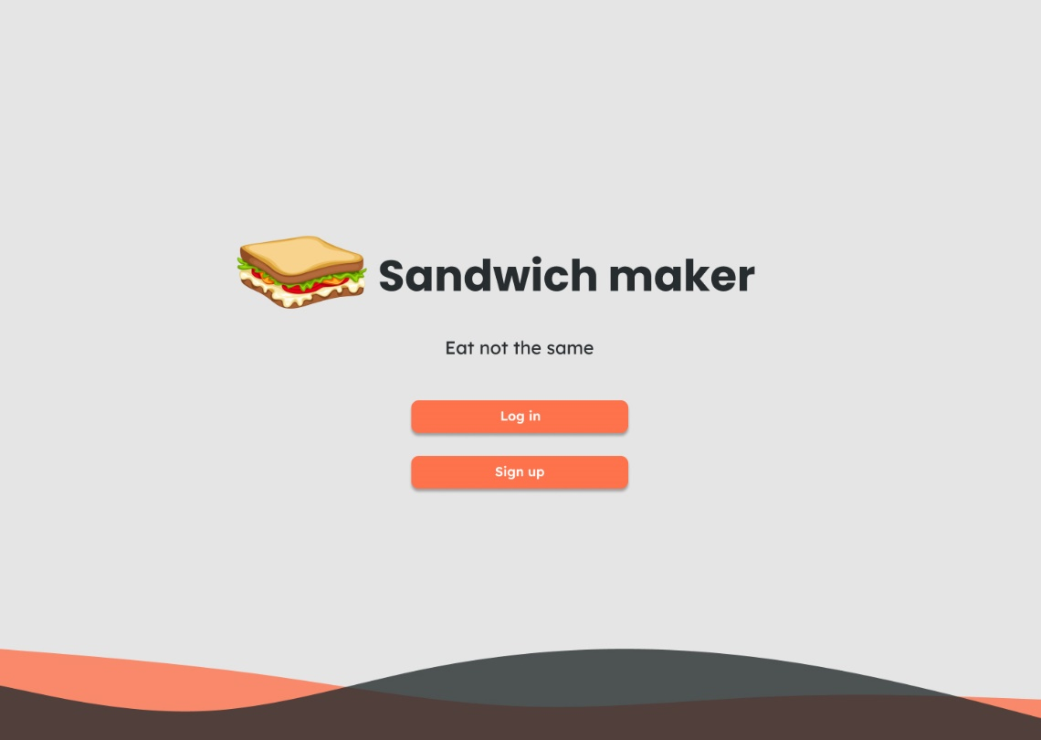

*Picture 3 - Welcome Page*

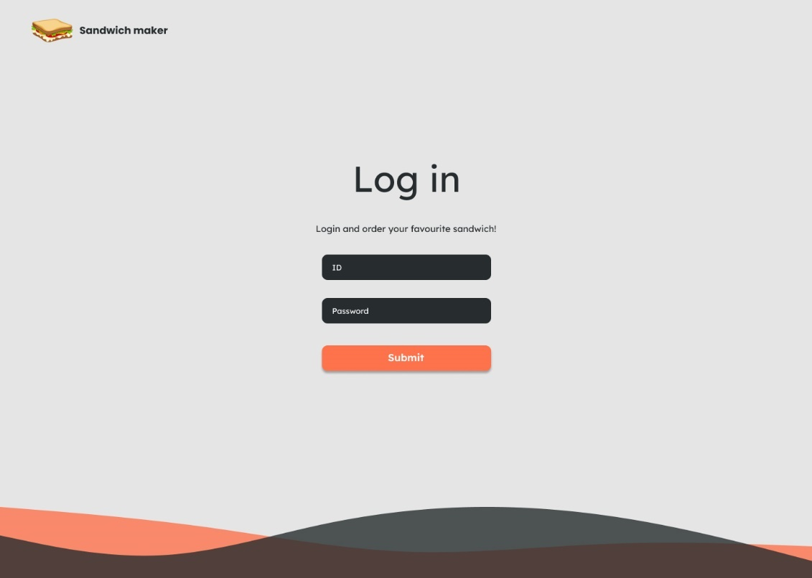

*Picture 4 - Log in Page*

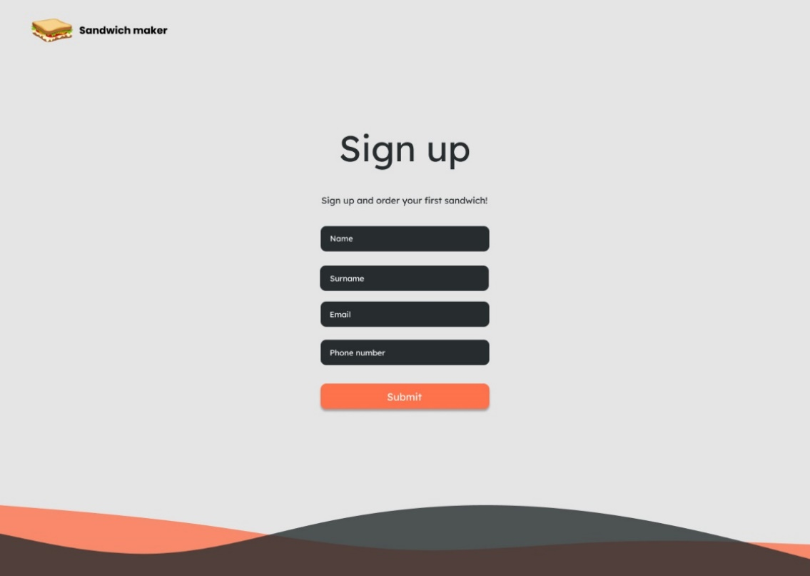

*Picture 5 - Sign up Page*

2. Logged in User (Customer or Assistant) see Main Page with a short „Sandwich Maker” description and a new special offer.

The Customer as a User has two options to choose („My Account” and „New Order” buttons in the right upper corner) while Assistant as a User has only one option (only „My Account” button in the right upper corner; no „New Order” button because Assistant can not make an Order from Assistant’s account).

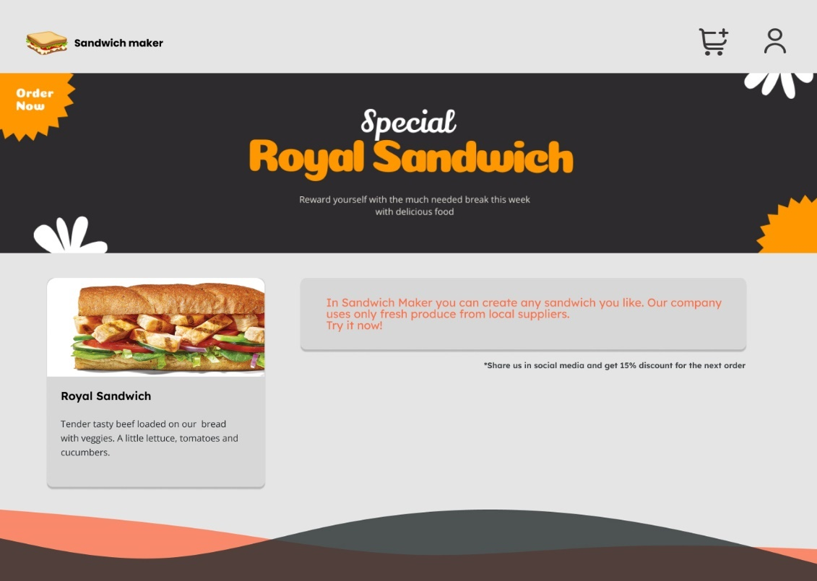

*Picture 6 - Main Page (Customer)*

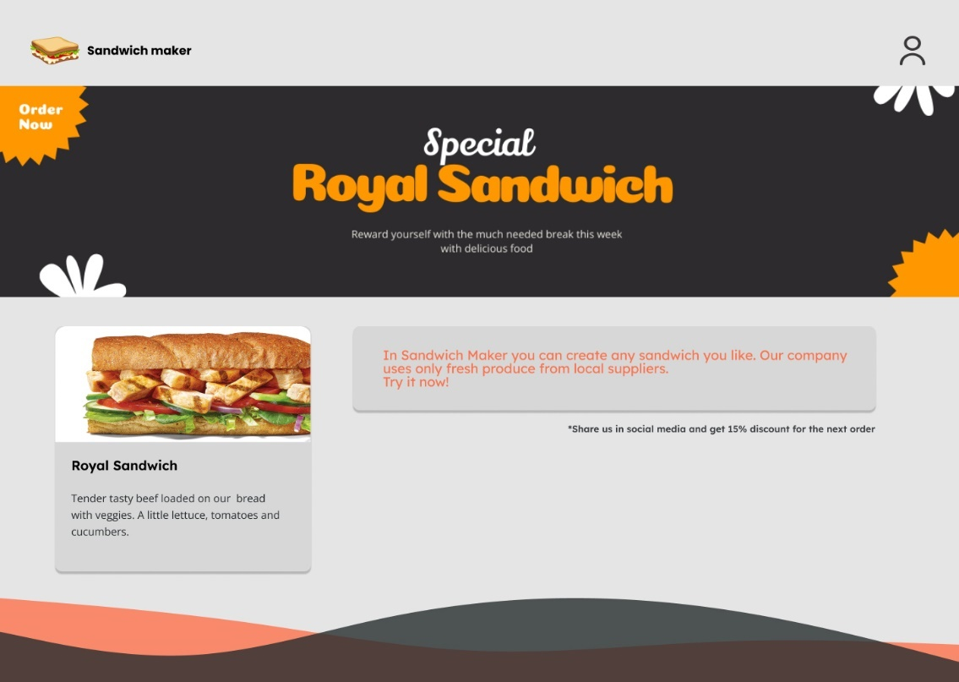

*Picture 7 - Main Page (Assistant)*

3. If logged in User as a Customer cliks on „New Order” button (a symbol of Cart in the right upper corner of Mane Page), then the Pick-up Point Page is displayed and making of new order can be started.

On the Pick-up Point Page the list of available points with their name, adress and working hours is shown. Customer needs to click on one of them in order to choose the point and next press „Submit” button to confirm a choice.

After the Pick-up Point Page the Menu Page with food menu of current Pick-up Point appears on the screen. Customer needs to click on desired Standard Positions ( in Standard Menu, Drinks, Sausce) in oder to coose them; or/and click on Custom Sandwich in order to choose this option and click on desired ingredients for Custom Sandwich. The quantity (number) of Standard Positions, Custom Sandwiches, ingredients should be enterd for each. Next press „Submit” button to confirm a choice.

Finally, a Payment Page with order details and total sum is shown to the Customer. On this page the payment method („Cash” or „Card” buttons) should be choosen. If Customers chooses „Card” as a payment method, then next Payment Page where card data (Card number, Valid Tru, cvc) should be entered and cliked on „Submit” button to confirm a choice. After that a Thank you for your Order Page with order number apperas and Customer needs to press „Main Page” button to return to Mane Page menu. If Customer chooses „Cash” as a payment method, then Thank you for your Order Page immediatelly displayed, too.

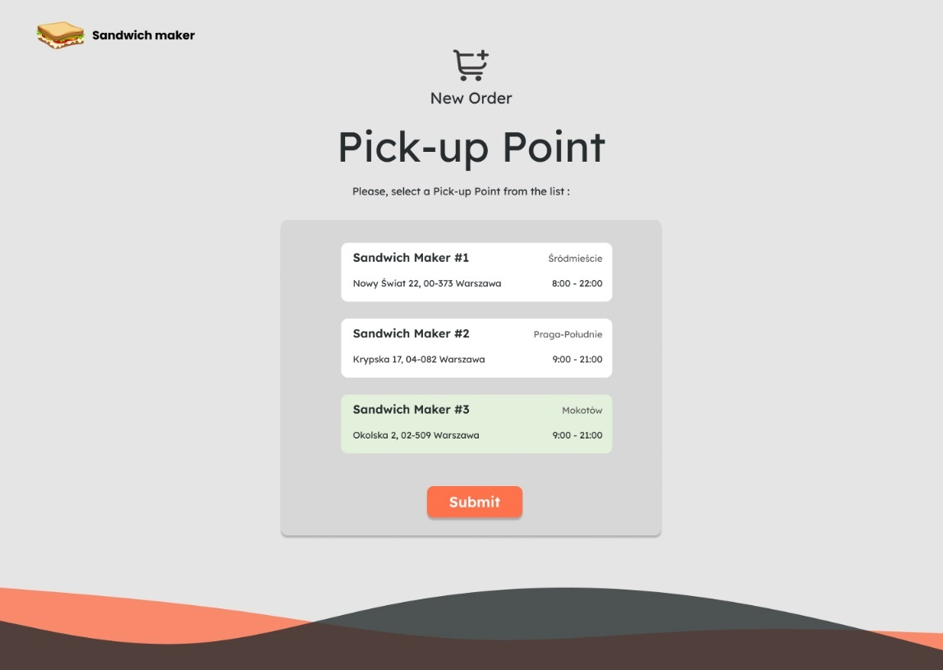

*Picture 8 - Pick-up Point Page*

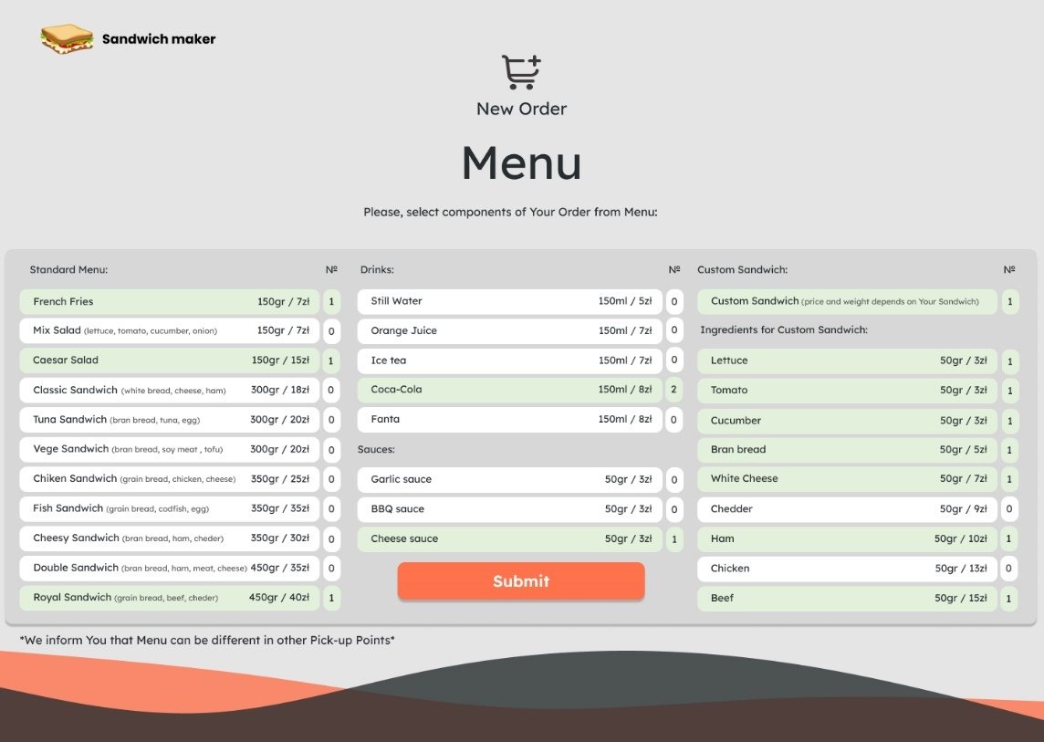

*Picture 9 - Menu Page*

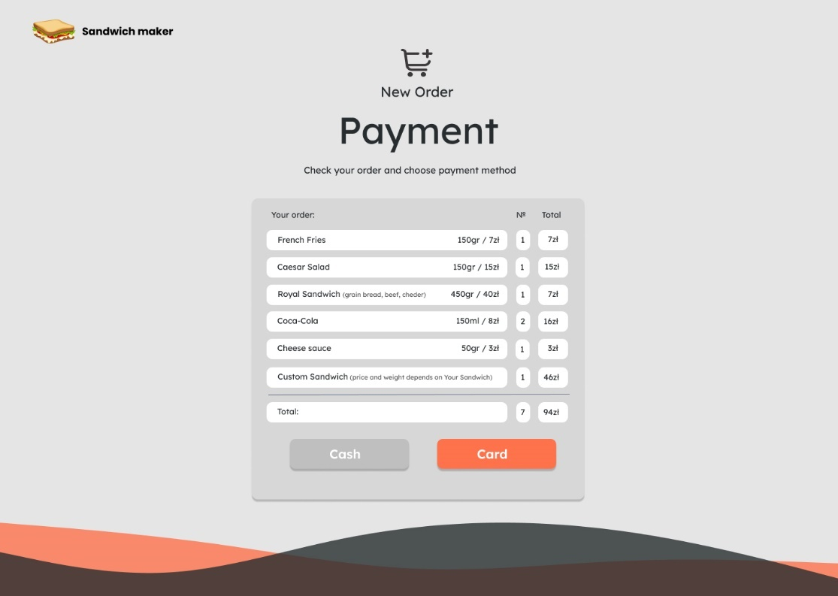

*Picture 10 - Payment Page (Order details and payment method)*

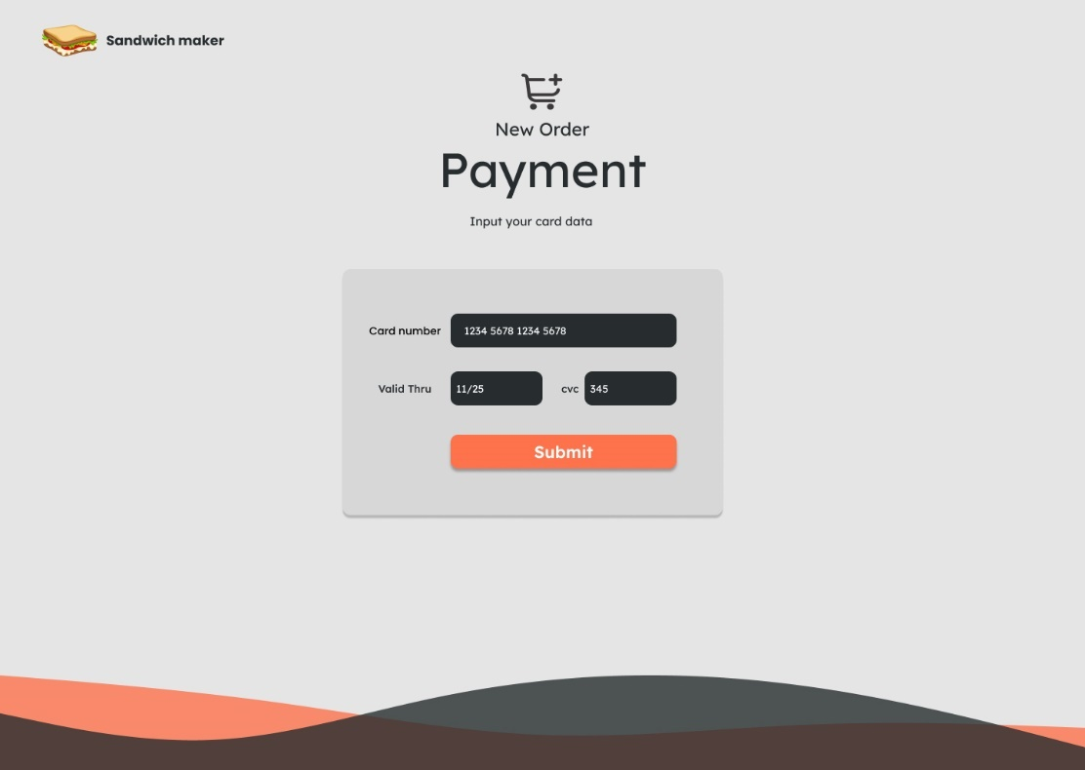

*Picture 11 - Payment Page (Card data; displayed only with Card payment method)*

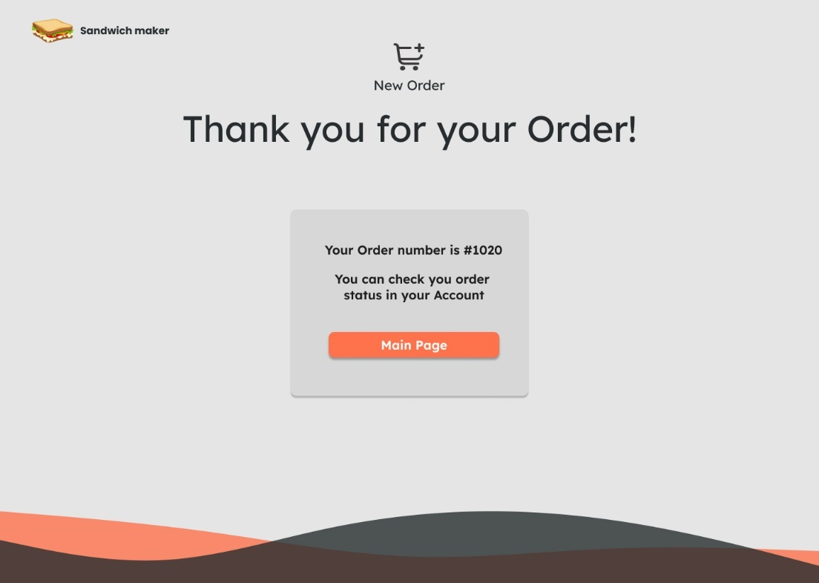

*Picture 12 - Thank you for your Order Page*

4. If logged in User as a Customer cliks on „My Account” (a symbol of a person on the right upper corner of Main Page), then My Account Page appears. Customer can press „Personal Data” button to see his personal info (Name, Surname, Email, Phone number), or click on „View Order Status” button in order to see View Order Status Page with a list of all his made orders and its statuses.

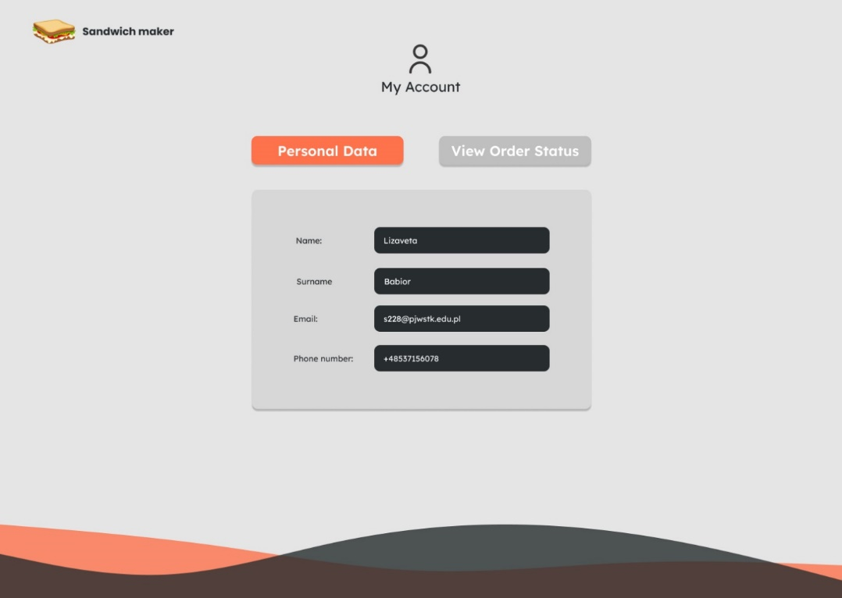

*Picture 13 - Personal Page (Customer „My Account”)*

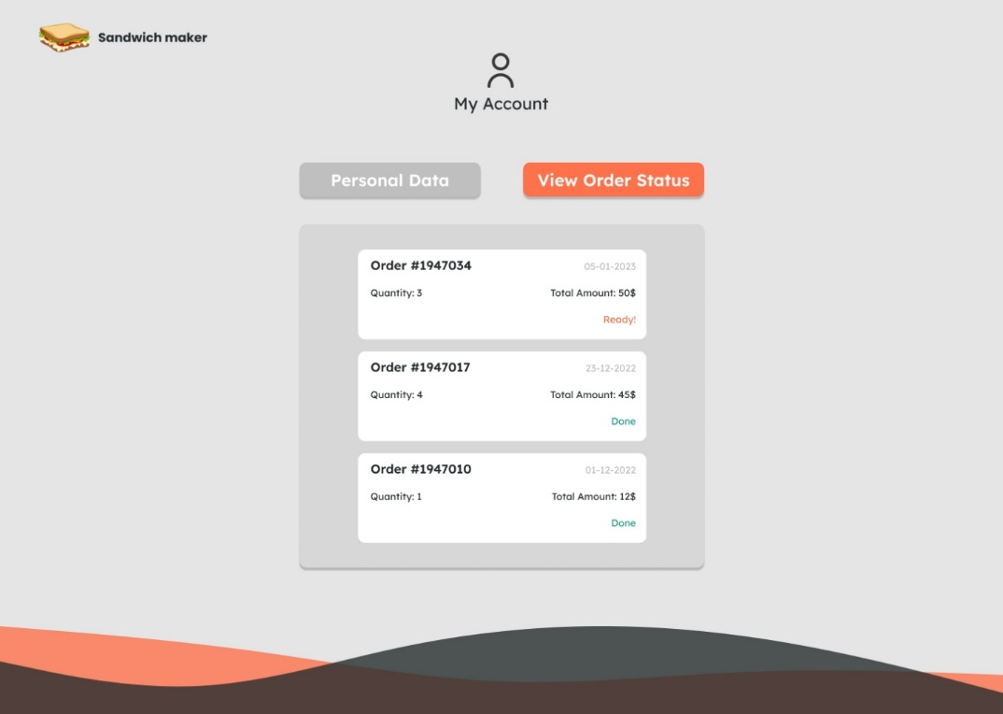

*Picture 14 - View Order Status Page* *(Customer „My Account”)*

5. If logged in User as a Assistant cliks on „My Account” (a symbol of a person on the right upper corner of Main Page), then My Account Page appears. Assistant can press „Personal Data” button to see his personal info (Name, Surname, Email, Phone number), or click on „Change Order Status” button in order to see Change Order Status Page with a list of all made (in one Pick-up Point) orders and its statuses. Asssitant needs to click on one from orders to choose it, enter new status and press „Submit” button to confirm the updates.

Assistant have two more options to choose: „View Order List” and „Make Stop List” buttons. If Assistant clicks on „View Order List” button, then View Order List Page with a list of all orders and its payment info („Paid by Card” or „Pay by Cash”) appears. If Assistant clicks on „Make Stop List” button, then Make Stop List Page, where Standard Positions or ingredient can be entered with their quanity (number), appears. In order to confirm a Stop List, Assistant needs to press a button „Submit”.

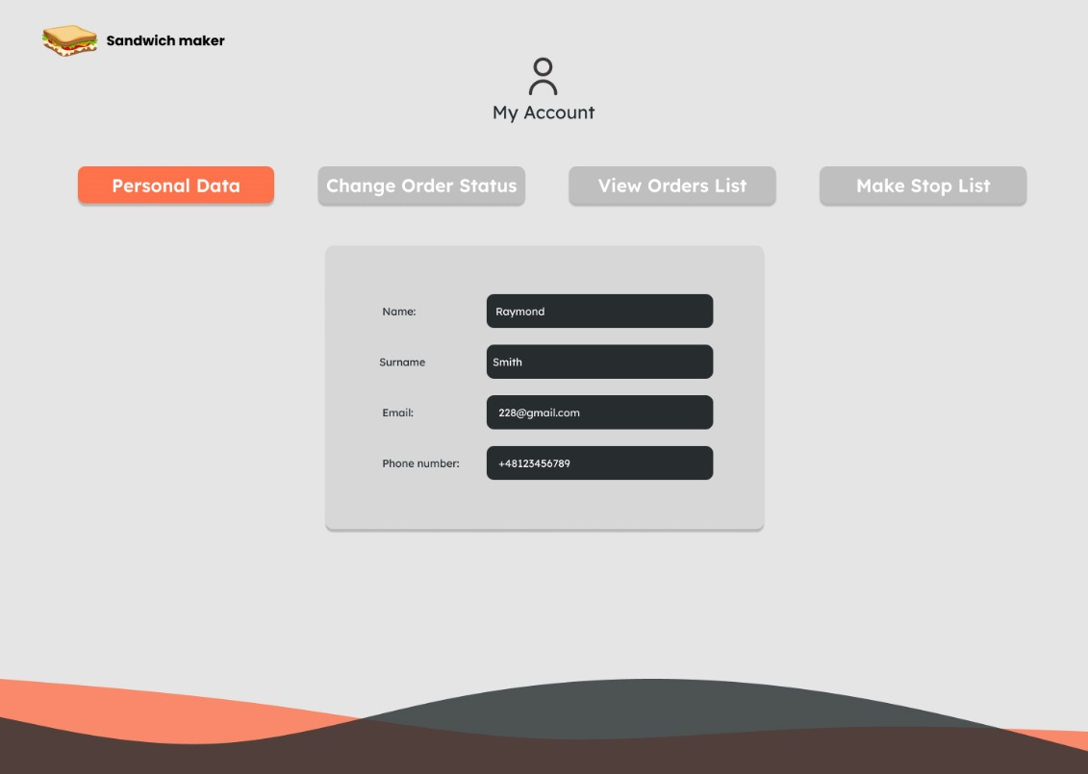

*Picture 15 - Personal Page (Assistant „My Account”)*

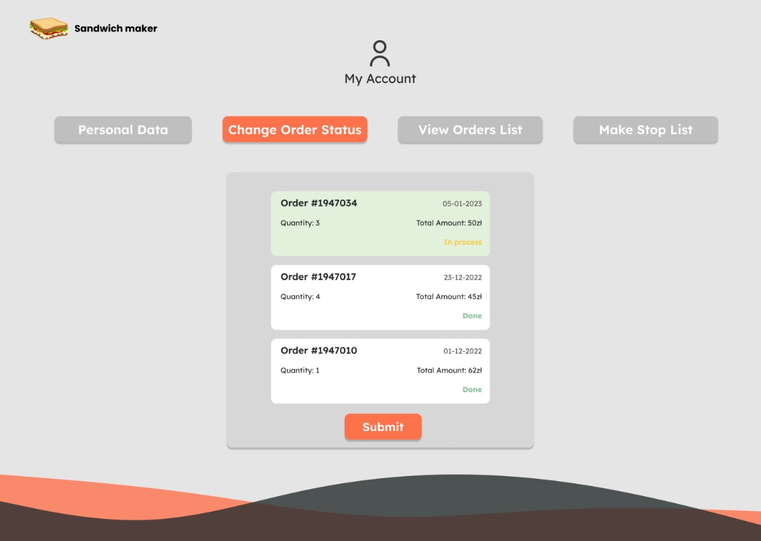

*Picture 16 - Change Order Status Page (Assistant „My Account”)*

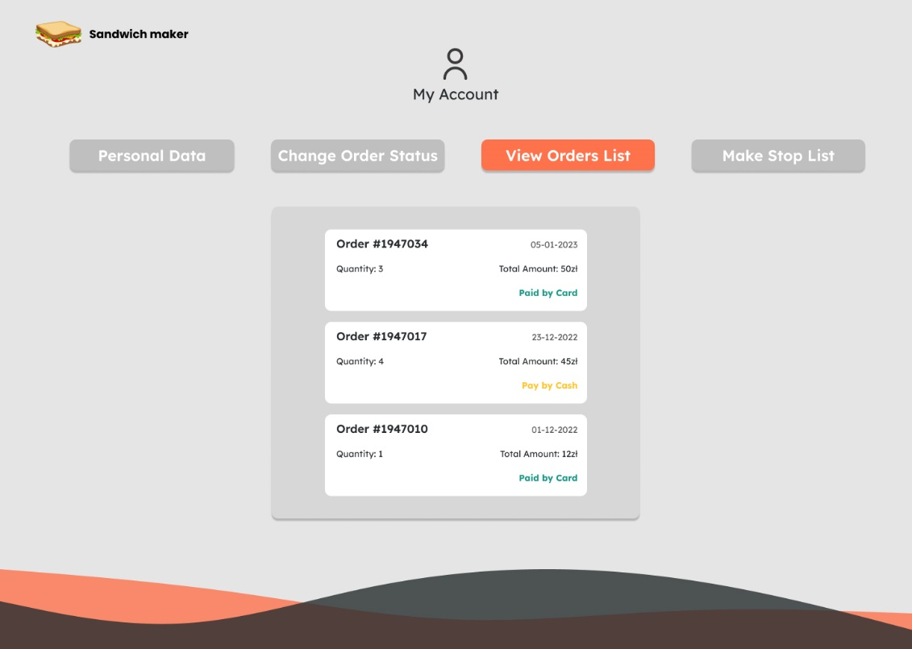

*Picture 17 - View Order List Page (Assistant „My Account”)*

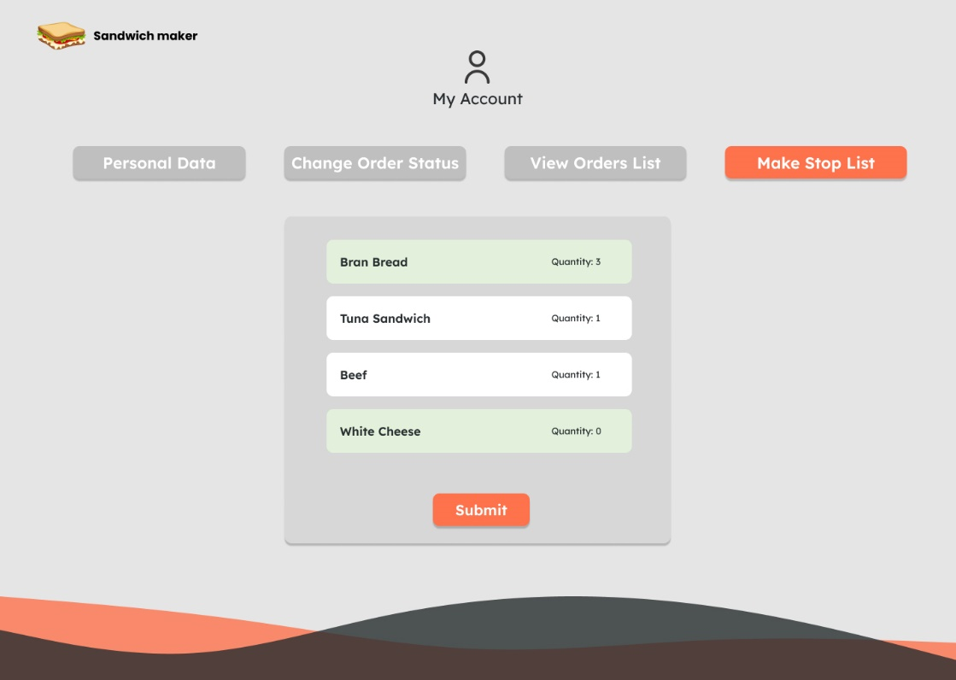

*Picture 18 - Make Stop List Page (Assistant „My Account”)*

# 5.0. Supporting Information

## Index

* „Guest” - 2, 4, 5, 10-13, 16-18.
* „User” - 2, 4-10, 12 – 18, 20, 21, 24, 25.
* „Stop List” – 2, 4, 6, 8, 9, 12, 13, 25, 27.
* „Standard Position” – 2, 5, 6, 8, 12, 13, 21, 25.
* „Custom Sandwich” - 2, 8, 12, 21.